RPM Report

Arthur T. Sredni

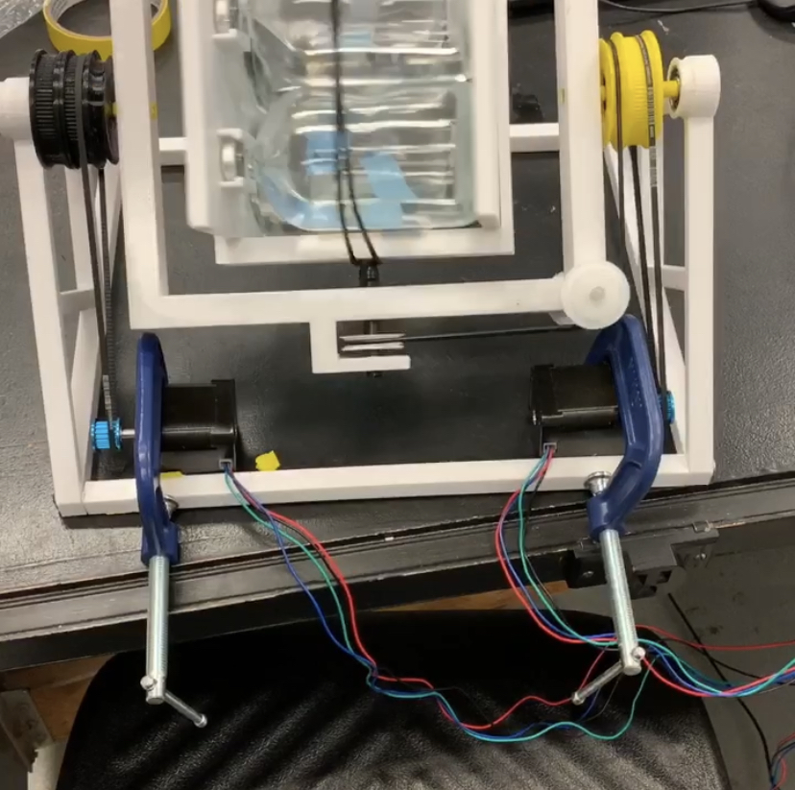

**Background**

The random positioning machine (RPM), also known as a three-dimensional clinostat, has been utilized for more than a century to study specimens at a simulated microgravity environment. The basic operational principle of the apparatus is to tumble an item in a sufficiently complex manner that will eventually cancel out –or minimize - the gravitational vector on whatever is being studied. In many ways, it can be seen as the opposite of a centrifuge, where instead of segregating substances to the bottom of a container, they are being constantly shuffled around inside of the random positioning machine.

When thinking of the design for this projects’ RPM, inspiration was taken from the apparatuses built between the 1920’s and 1980’s, as the new machines are too specialized and complex for the needs of our microbial project. We were mostly influenced by an RPM built by Dutch Aerospace (now known as Airbus Defense and Space Netherlands). The design is comprised of two frames, each spinning on a different axis, at different rates with only motors at the bottom of the apparatus running a series of belts to drive the machine. Unlike previous designs, our plans were modified for the machine to carry bottles instead of petri dishes.

**Materials**

Instead of attempting to come up with a new design, we mostly focused on replicating the existing RPM designs on a much-reduced budget by utilizing fused deposition modeling and off the shelf components. The Bill of Materials is as follows:

|  |  |  |
| --- | --- | --- |
| No. | Component | Quantity |
| 1 | Polyethylene Terephthalate Glycol (PETG) Filament | 700g |
| 2 | MXL Series Timing Belt (1/8 width, Trade No.168mxl012) | 2 |
| 3 | Ball Bearing (7/8in housing) | 5 |
| 4 | Oil-Resistant Buna-N O-Ring (3/32 fractional width, Dash Number 163) | 1-3 |
| 5 | Stepper Motor (Nema-17) | 2 |
| 6 | Nema-17 Motor Pulley | 2 |
| 7 | Arduino Uno | 1 |
| 8 | TB6600 Driver Boards | 2 |
| 9 | Screws (Available and Reasonable size) | 4 |
| 10 | Aluminum Rod (preferably 0.8mm in radius) | As needed |
| 11 | 2-1/2in C-clamp | 2 |
| 12 | Super glue | 1 |
| 13 | Masking Tape (Roll) | 1 |

**Assembly**

Inner Frame:

The inner frame of the machine is composed of two identical plates and additional all-encompassing frame. The plates can be seen below:

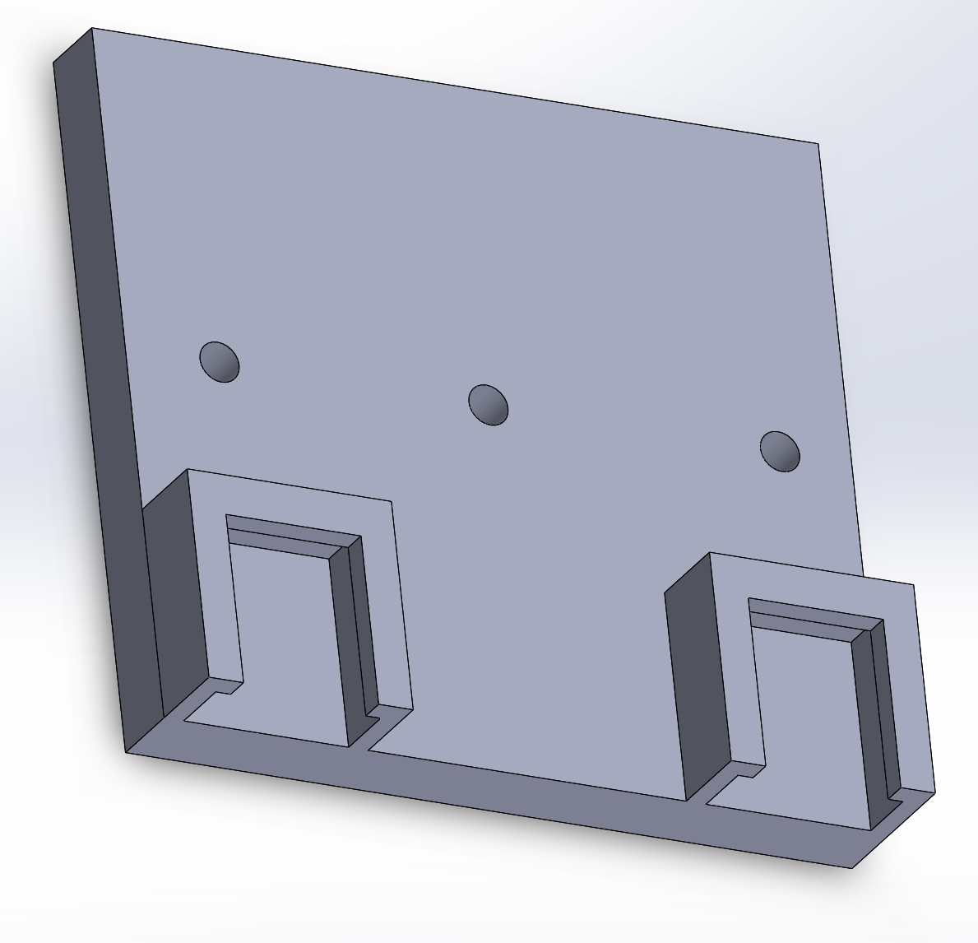

The inner encompassing frame can be seen below:

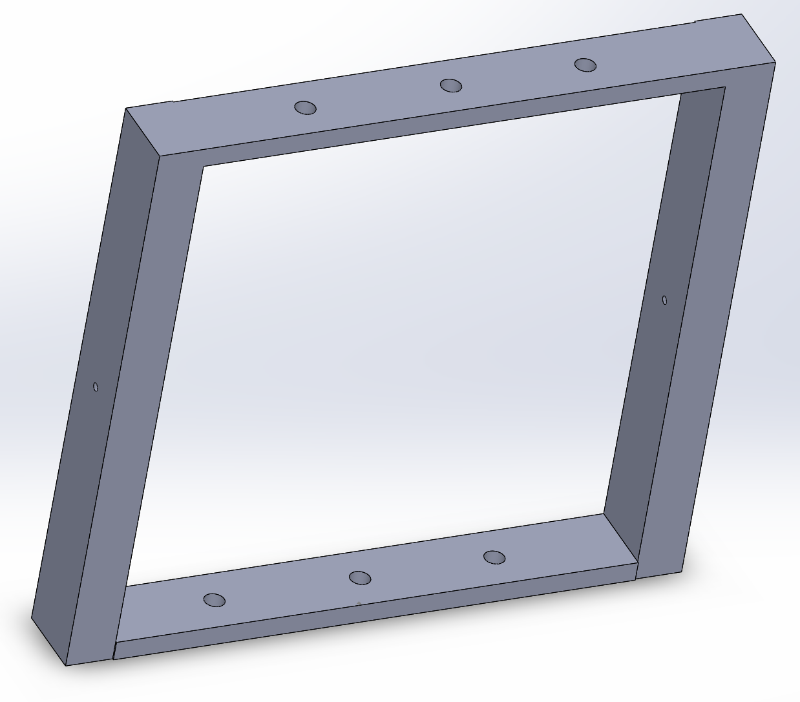

This is how both parts look when assembled:

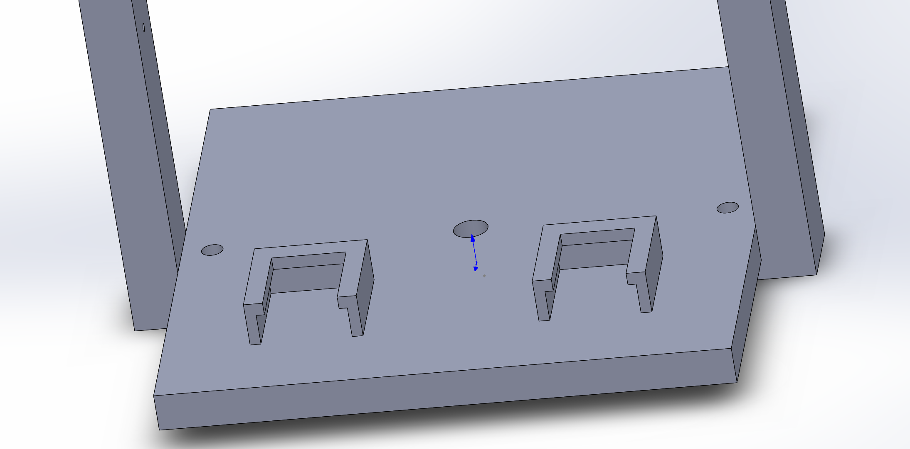

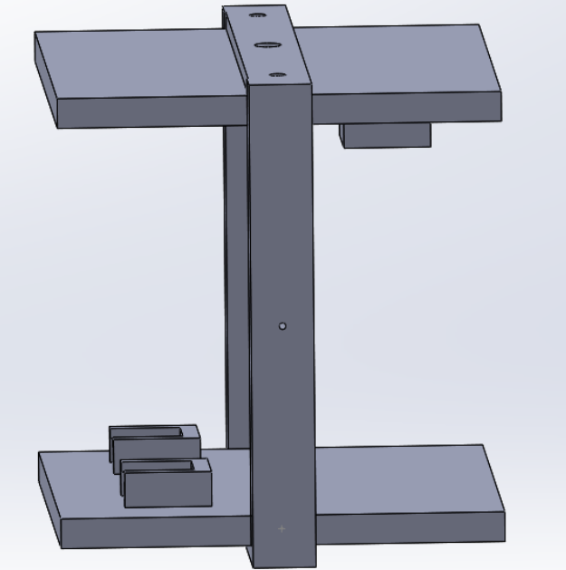

The initial design called for the inner frame assembly to use screws secured by bolts through the two smaller holes at each end of the frame to secure the plates. However, to avoid warping of the printed parts, which only has a 20% fill, super glue was used instead of screws. An aluminum rod was placed through the center hole, secured by superglue, in order to facilitate its rotation and provide a way to secure it to the outer frame.

Outer Frame:

The outer frame of the random positioning machine was made of one large 3D printed part with attachment points for the base, inner frame, pulleys, and pulleys.

The frame can be seen below:

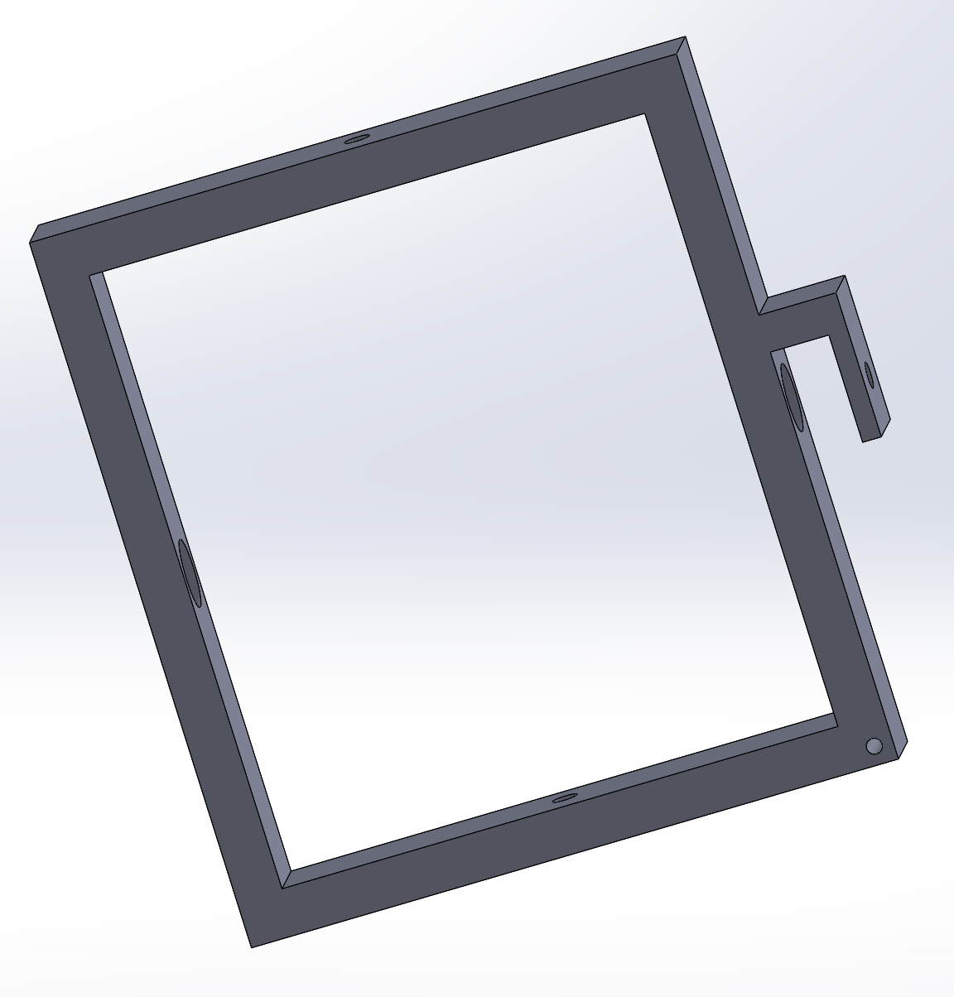

The protrusion on the frame is used in order to be able to place a pulley needed to help drive an O-ring to rotate the inner frame. The large holes on both the top and bottom of the frame are meant to house bearings. Going through all these holes is the aluminum rod secured to the inner frame and mostly secured through pressure and tape. The figure below represents the assembly of the components:

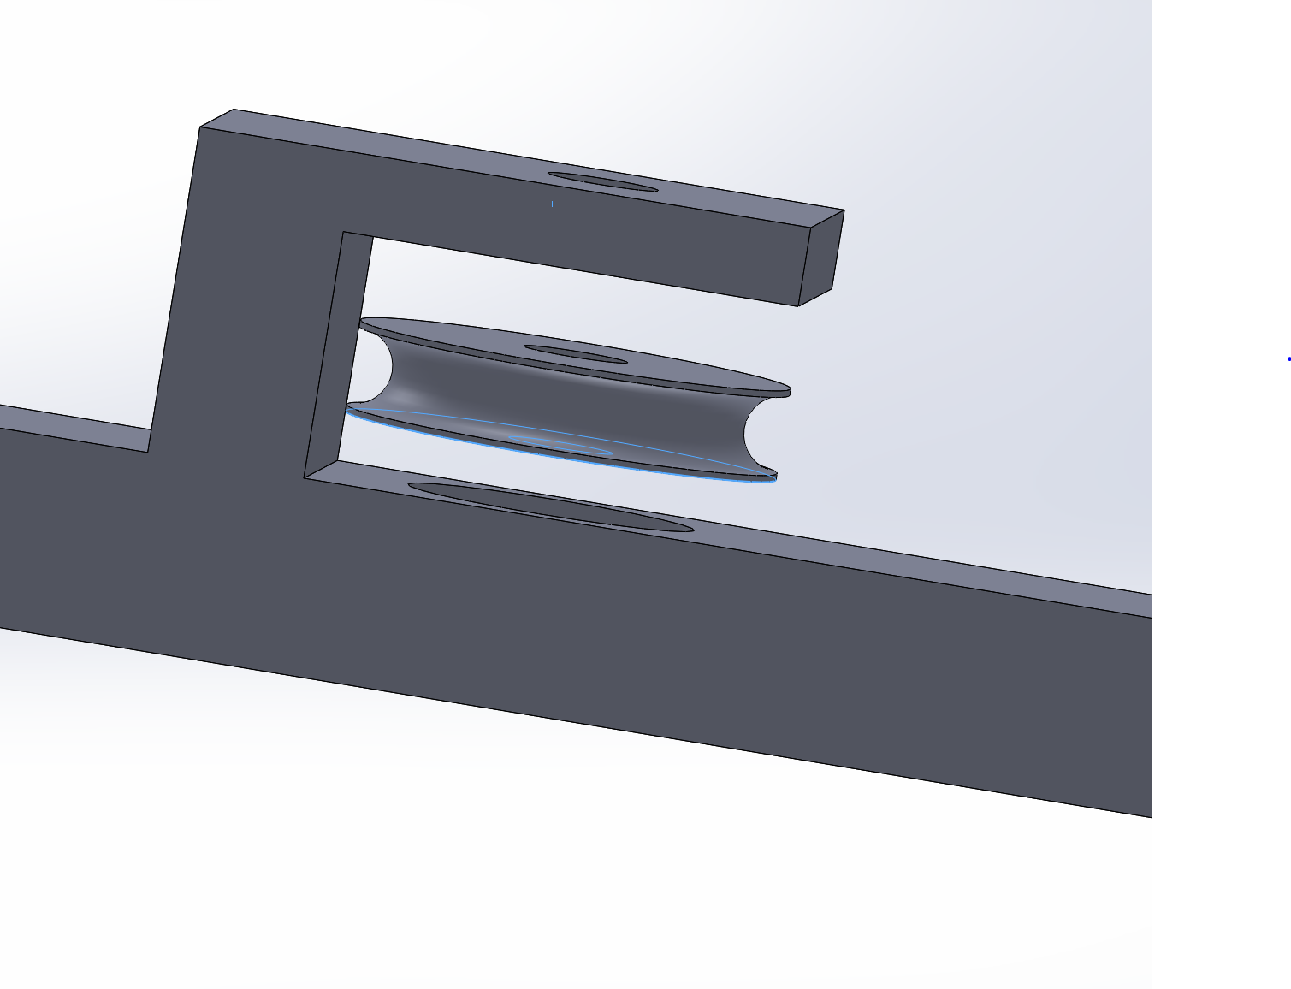

Additional pulleys were needed to assist in driving the O-ring, which are secured to the ends of a small aluminum rod which super glue and allowed to rotate. These can be seen below:

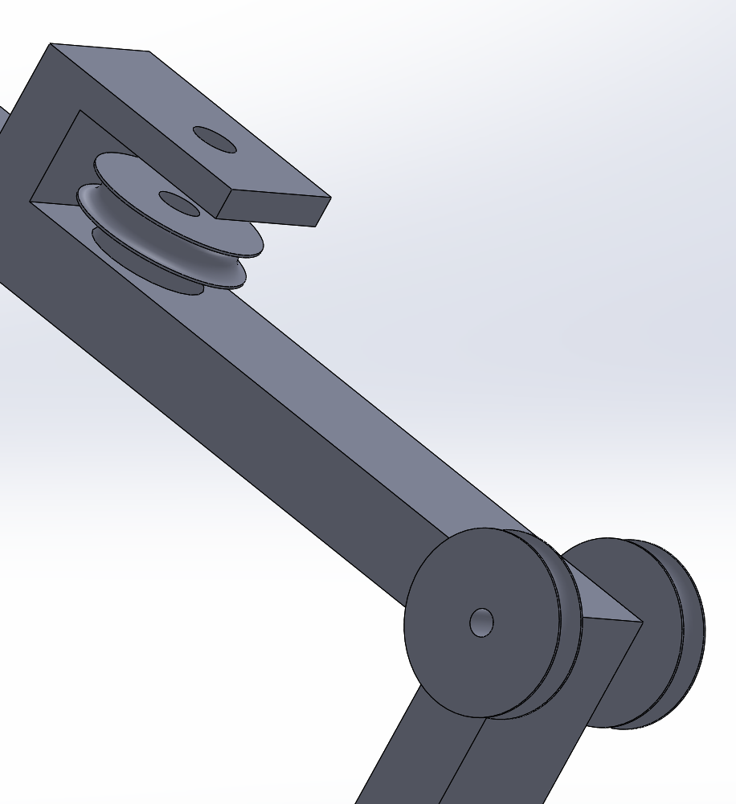

On both sides of the outer frame, pulleys had to be placed. On the side that did not necessitate the that the O-ring be placed around, a special pulley with groves made for an mxl series drive belt was fixed to the frame, since this will drive the movement of the outer frame. The pulley can be seen below:

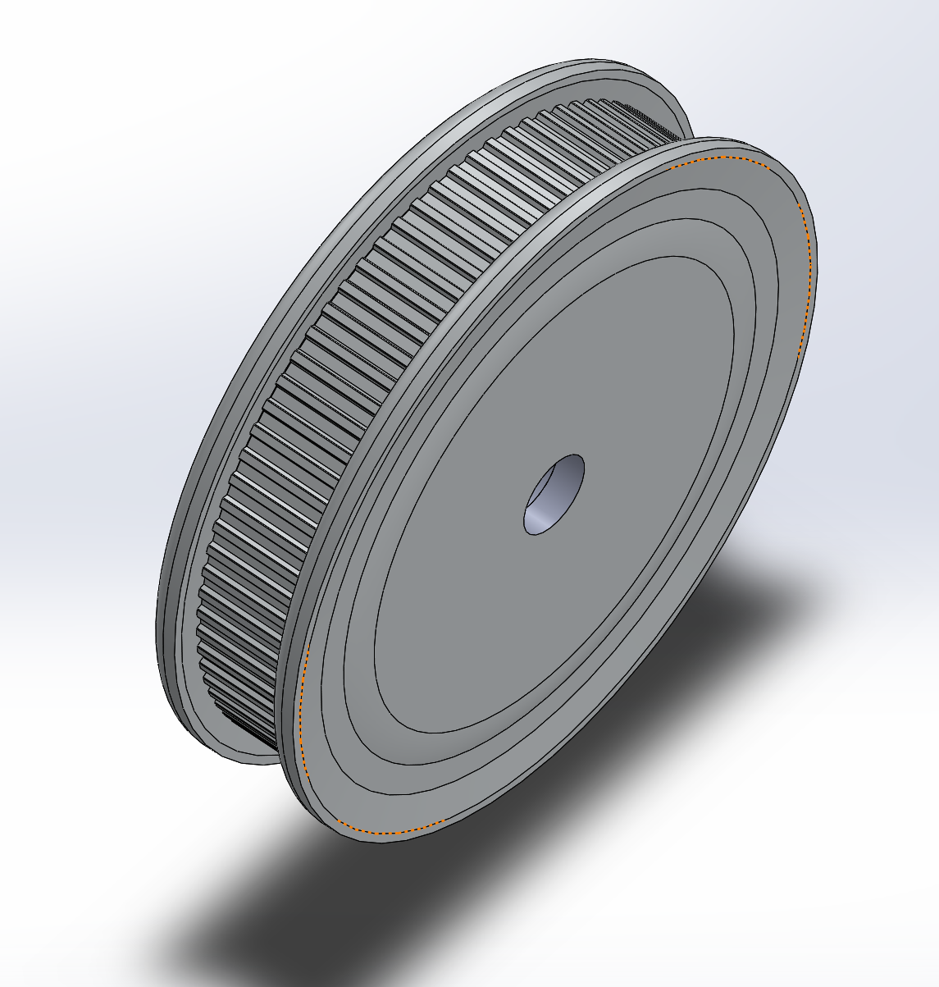

When placed adjacent to the outer frame, it looks like this:

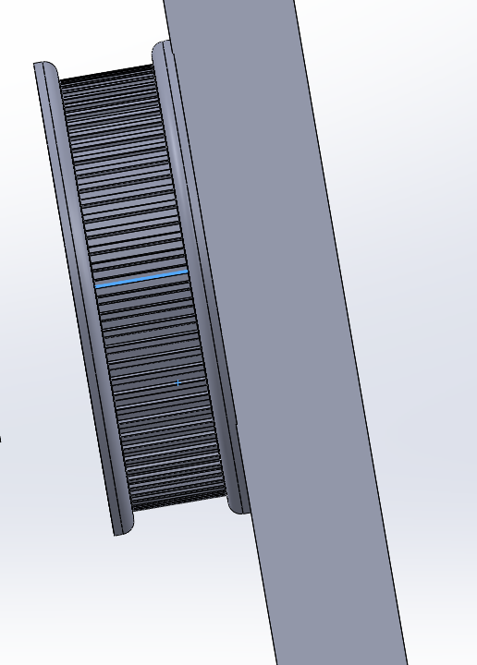

Meanwhile, the pulley placed onto the other side of the frame, needed to drive the O-ring for the inner frame to rotate independently. Originally, a simply molded part with a geared and ungeared pulley combined was used, and the metal rod which attached it to the other frame was secured with any adhesive in order to allow for rotation. This pulley can be seen below:

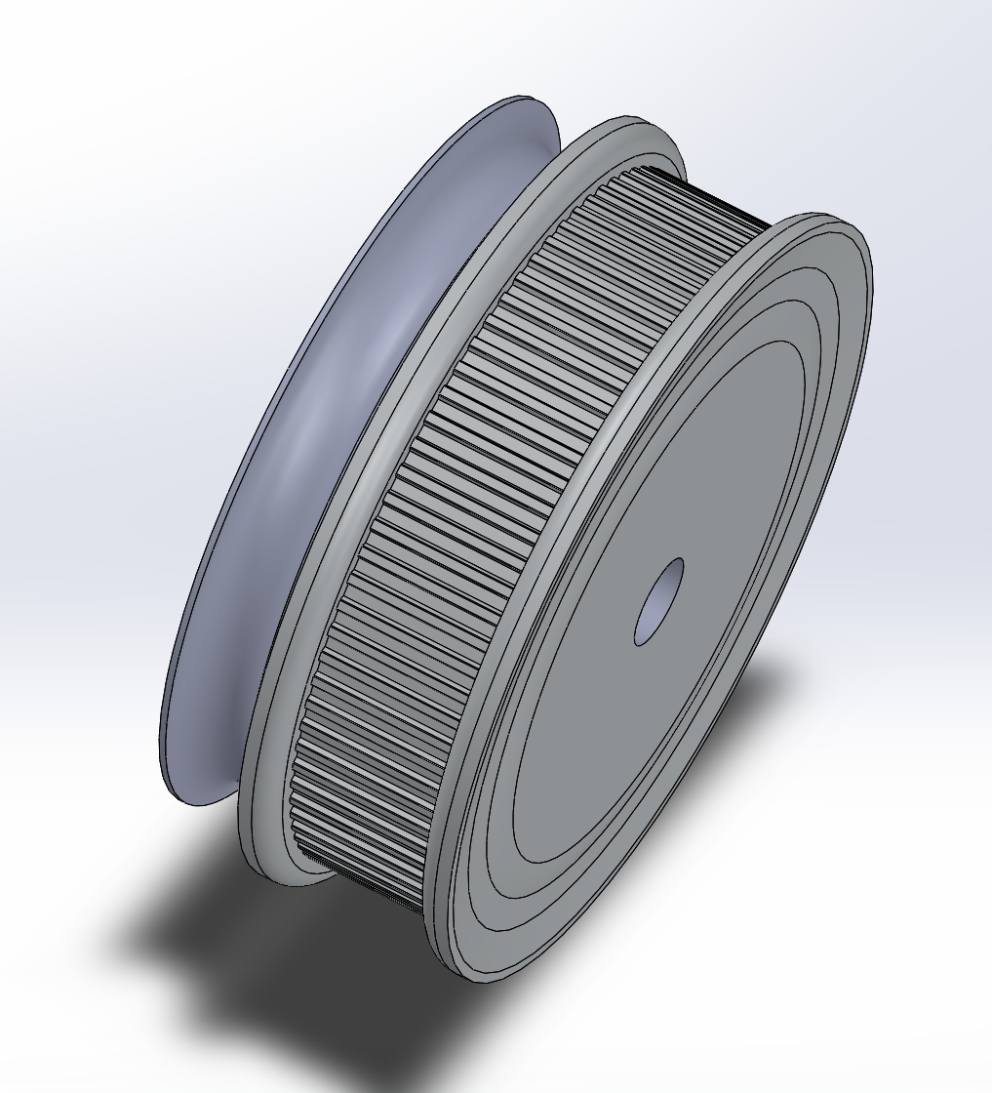

The entire assembled outer frame looks like such:

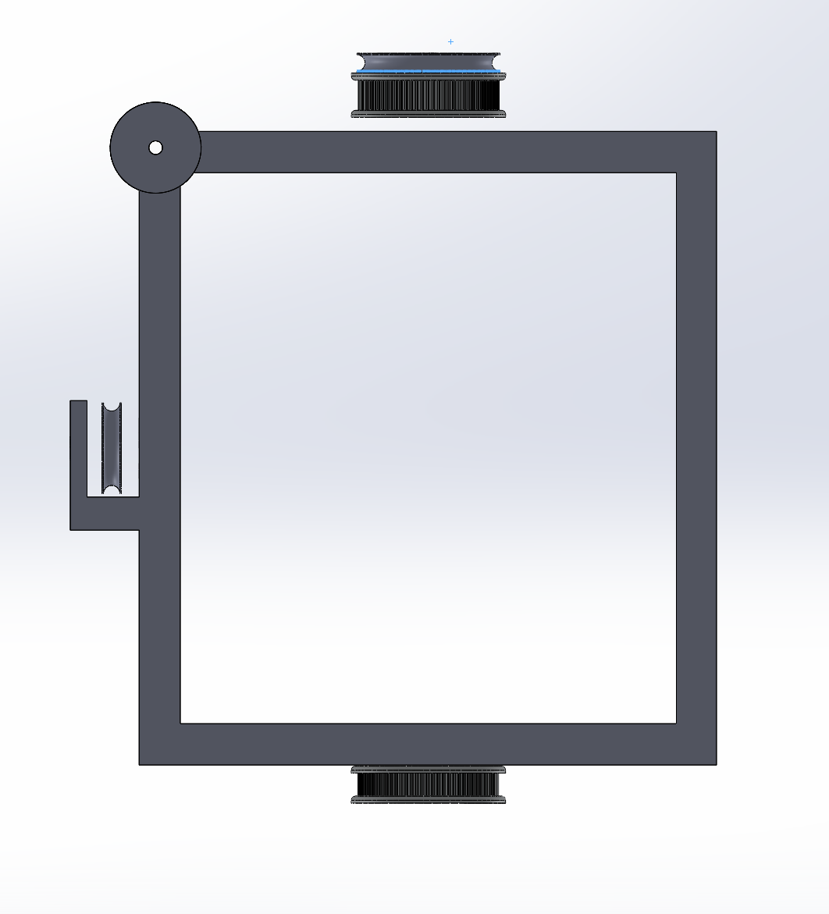

Base:

The base of the structure is composed out of two trusses, where bearings can be mounted, and two rods to connect them. All parts were attached with screws from holes which were bored onto them after printing. Each truss accommodates two bearings at the top circular hole, to assist with rotation and provide support for the aluminum rod fitted through them and the inner frame. Next to the rods, Nema-17 servo motors are placed in order to run the belts to drive all pulleys and rotate both frames. The truss can be seen below:

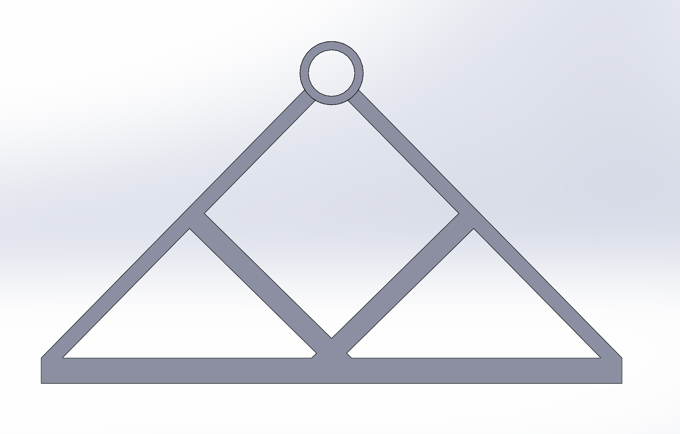

These are the rods which were printed:



When assembled they looked like this:

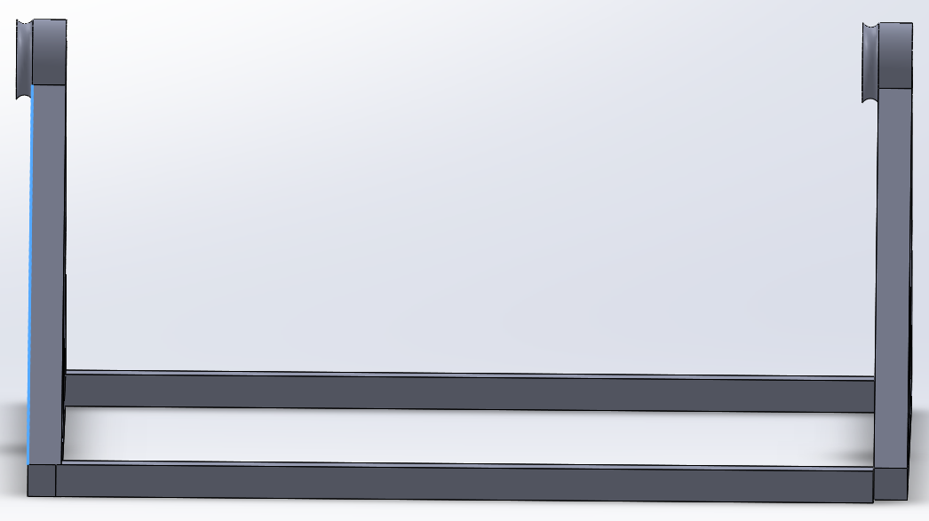

Due to changes made after fabrication, the orientation of the base trusses is irrelevant.

The motors, with the belts running through them had to be affixed to the base by utilizing c-clamps, as can be seen here:

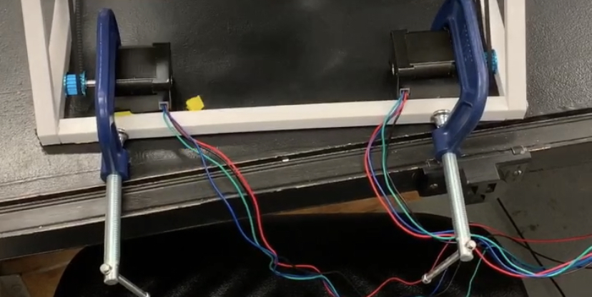

Final Assembly:

When all constituent parts are made and fitted to one another, through the aid of screws, super glue and tape (used in order to get a tighter fit between rods and holes, when an open gap might prevent the optimal operation of the machine). Many small adjustments must be made due to the high tolerances and variability present in 3D printing.

**Mistakes and Adjustments**

When constructing the random positioning machine, many mistakes were made which had to be corrected. Here is a list of changes to the design which had to be made in order to make the machine fully operational:

* There was a discrepancy between the size of the rods, and holes
  + Fix: Utilize tape to bridge gap when the hole is large
  + Fix: When printing a part with holes, printed to be more than marginally larger than what the design calls for
  + Do Not: Bore the hole to make it bigger, especially when using a low percentage fill (20%-40%)
    - We did this to attach the base together, as superglue was not enough to overcome the vibrations from the motors. If I were to construct this again, this part would have been redesigned.
  + Note: Tight fits will provide support and allow for better rotation
* The original design for the pulley needed to run the O-ring and the inner frame proved to not move independently enough.
  + Fix: Utilize a new design for the pulley, with a bearing at its center
    - Addendum: The motor for this pulley does not necessarily need to be turned on as the inner frame can derive its movement from the stretching of the O-ring as the outer frame rotates
      * For this to work, the O-ring pulley must be held stationary, this can be accomplished by utilizing the belt and motor to force it into not rotating with the outer frame.
      * This was the new pulley design used:

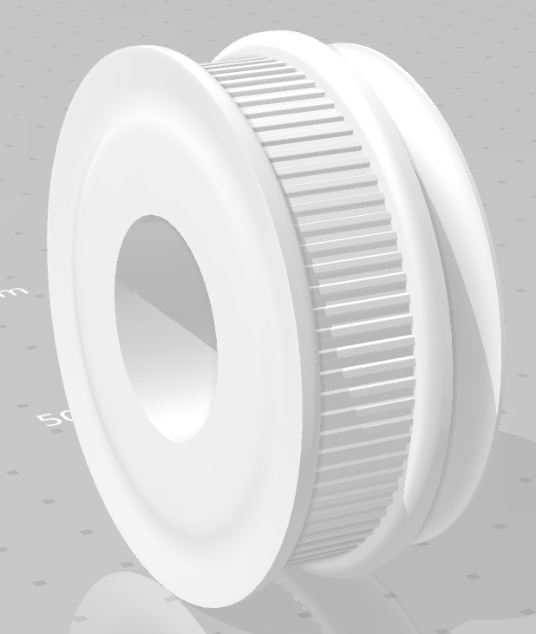

* Heat became a major source of problems for our electronics. When they reach a heat point, motors and boards tended to shut down
  + Fix: Only buy boards that were specifically designed for the servo motors being used in the project. (In our case, for Nema-17 motors, TB6600 drivers were used)